**Perform Data Visualization:**

**Perform the following using charts and visuals:**

1. Analyse the *Sales/Profit* for all the months of 2017 as a continuous line chart and area chart.

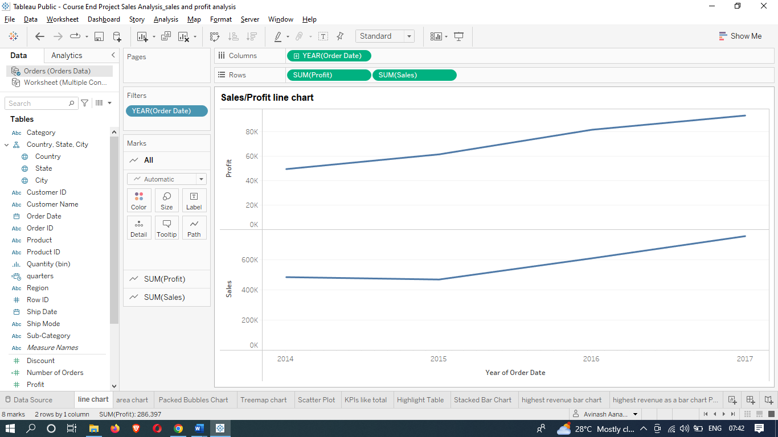

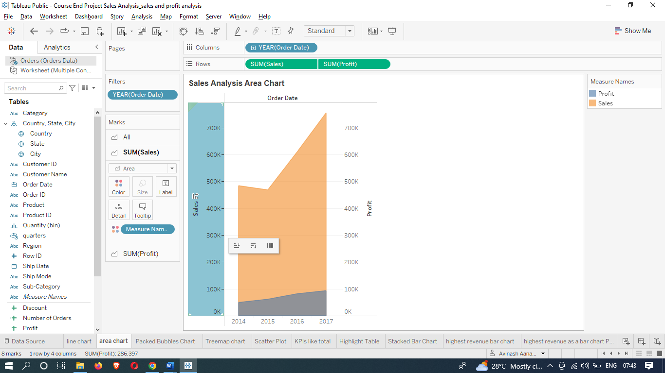

1. Show *Category-*wise *Sales* as Packed Bubbles Chart suggesting categories with highest to lowest sales.

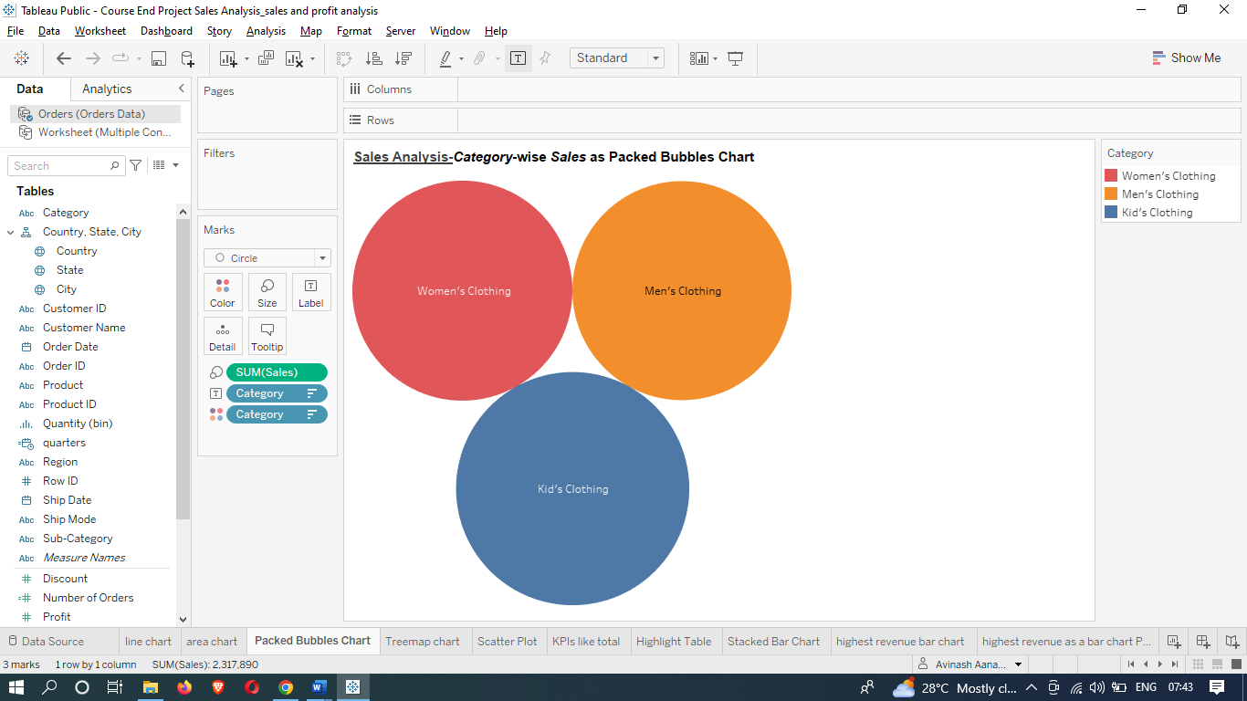

1. Create a Treemap chart showing *Sales* by *Category* and *Sub-Category*.

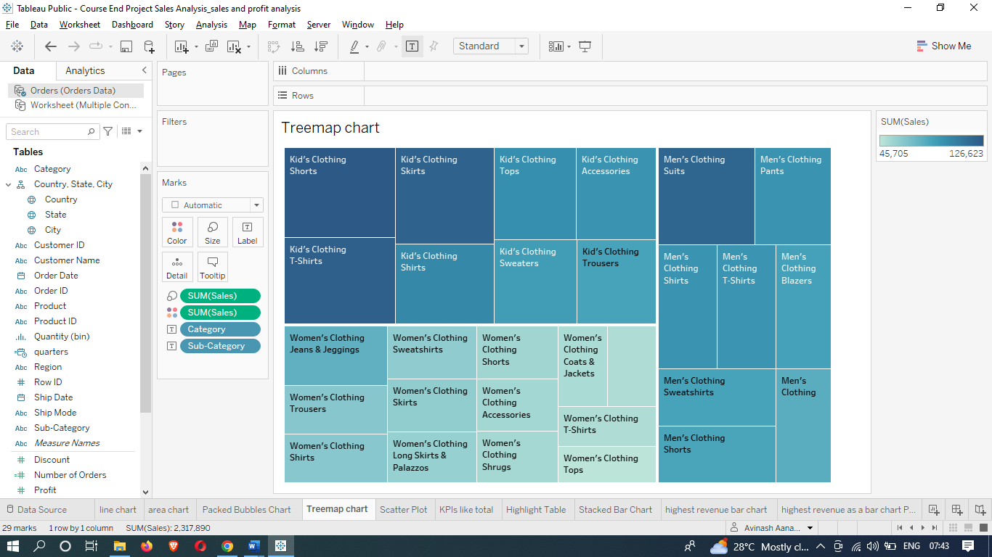

1. Visualize *Sales* vs *Profit* on a Scatter Plot with *Category* and *Sub-Category* breakdown.

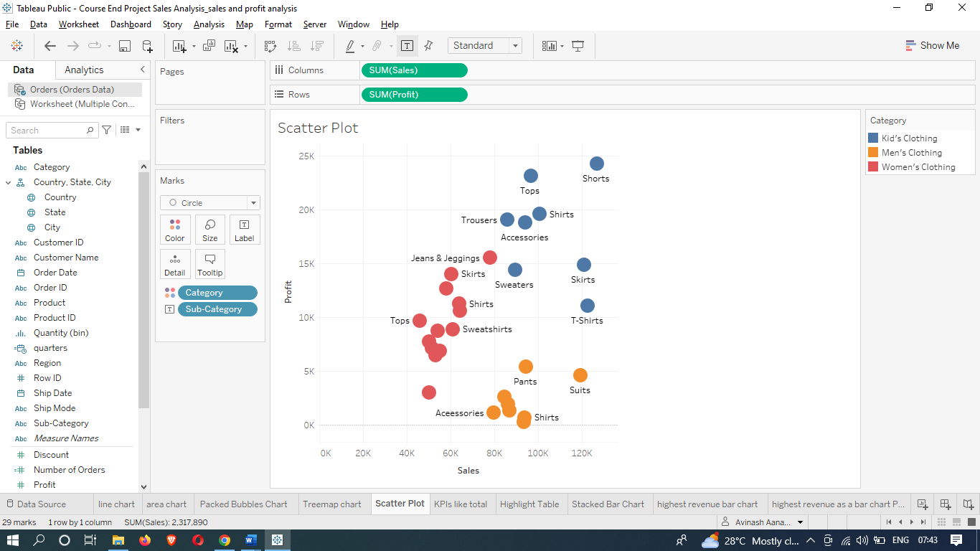

1. Compute aggregated values for all Sales KPIs like *Total Sales, Profit, Profit Ratio, Discount* in a Table view.

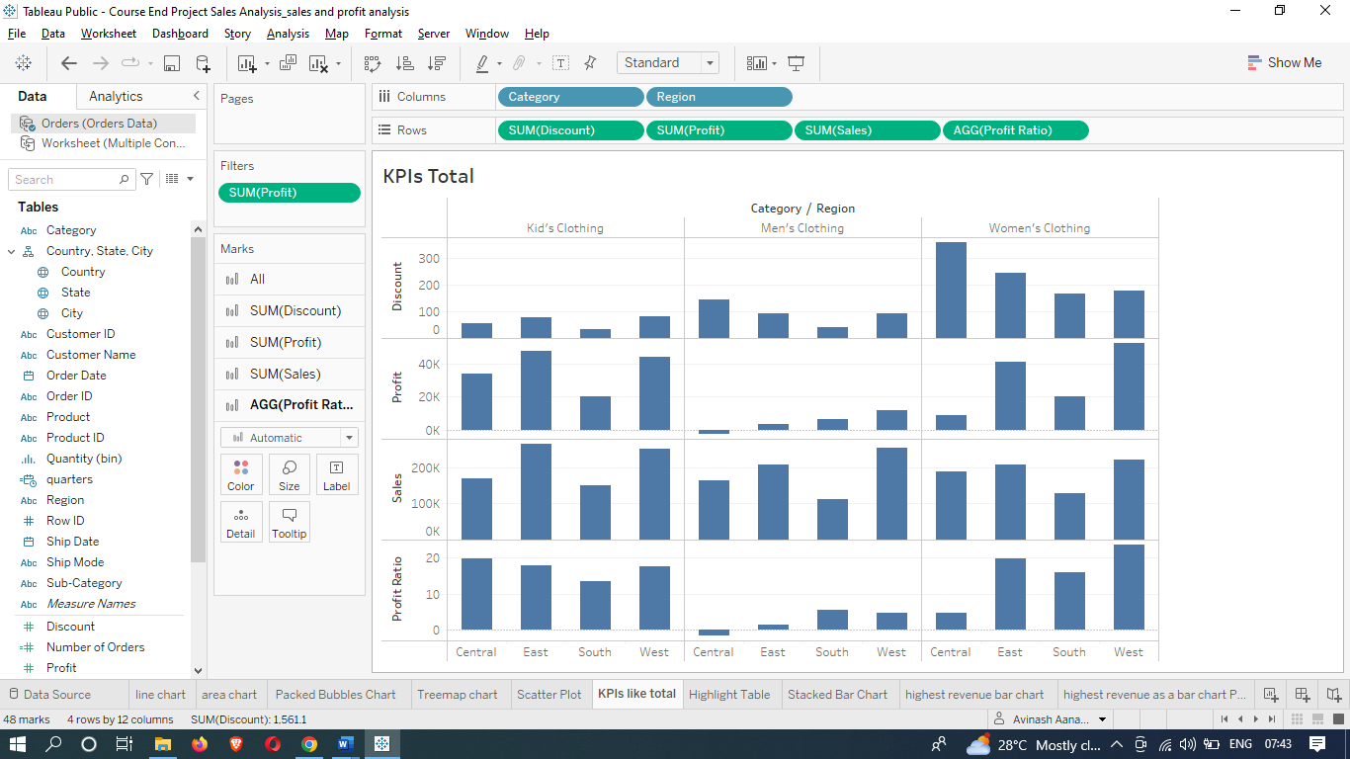

1. Analyse the *Sales* for all the quarters of all the years across *State*, and *Category* as a Highlight Table. Highlight the columns by Profit.

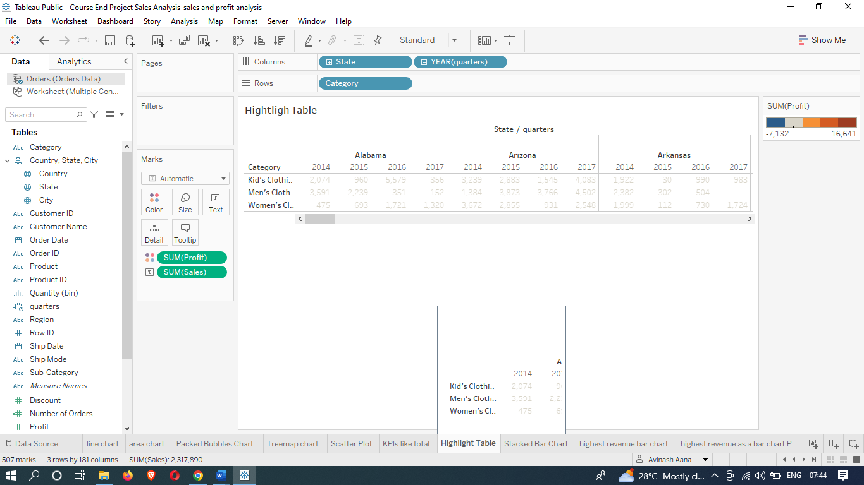

1. Connect to the ***Return Data*** dataset, and blend it with ***Orders*** data to compute the *number of orders returned* for each Product *Category* in 2016.
2. Show *Sales/Quantity* of Product *Category* in each *Region* as a Stacked Bar Chart.

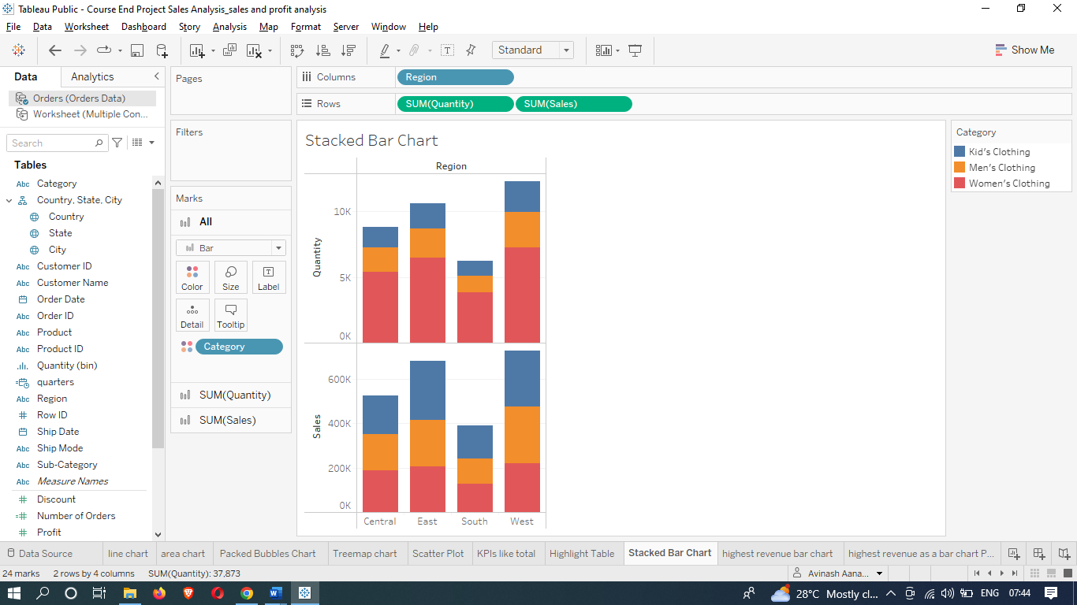

1. Determine the top 5 *products* and top 5 *customers* by *Sales*, i.e., *Products* and *Customers* that are generating the highest revenue as a bar chart.

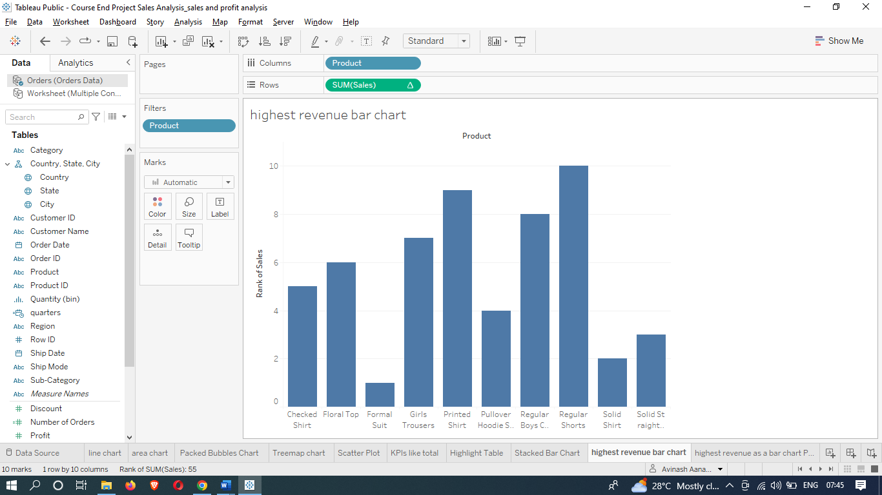

1. Visualize *Sales* by *State* where the sales variation is highlighted by color as a Map Chart.

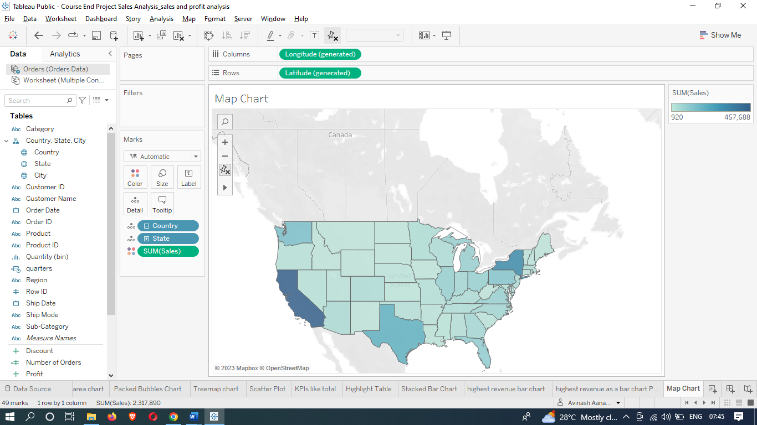

1. Visualize Sales & *Profit* analysis by *Customer* on a Scatter Plot.

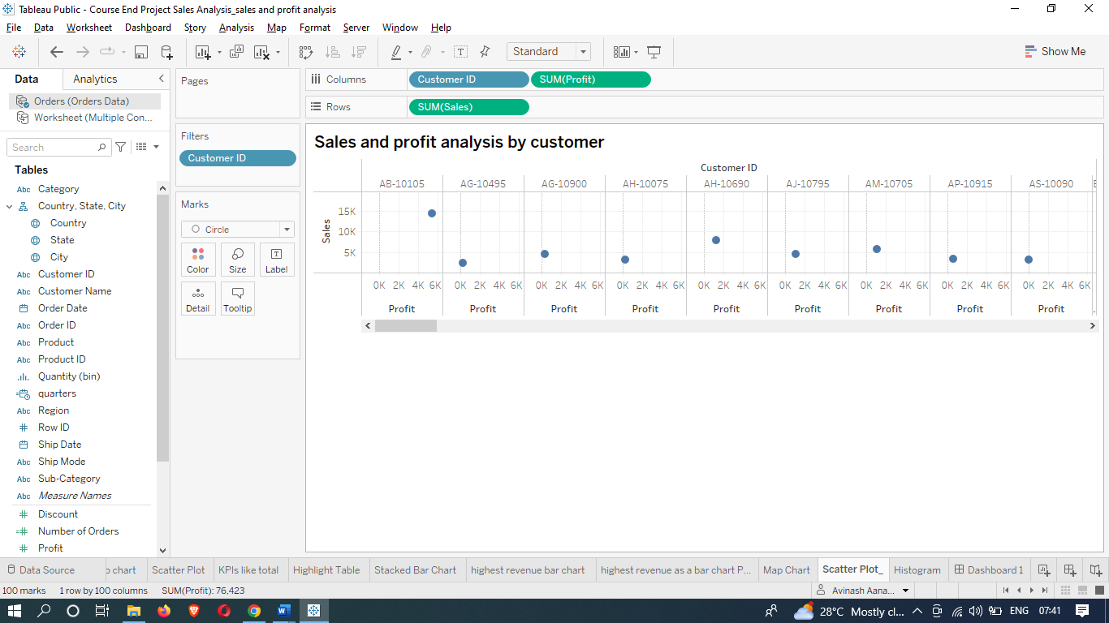

1. Represent the *Number of orders* received by *Quantity* bins as a Histogram.

* Create Quantity bins.
* Use Measure Count of Quantity as calculation.
* Drag Count of Quantity in Row Shelf and Quantity bins in column shelf

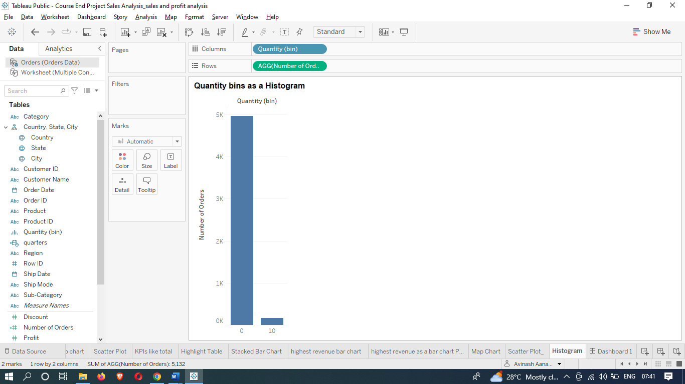

1. Create an interactive fixed size floating layout Dashboard that can be shared with the leaders using the above analysis.

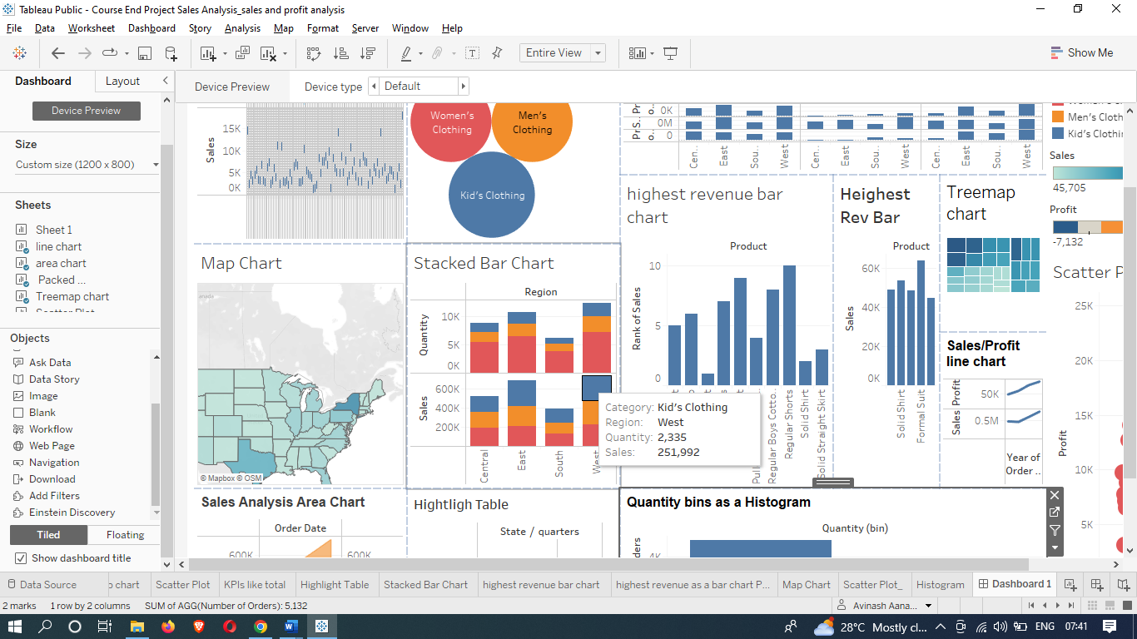

14. Create a story with the following visuals:

*\*Note: The below-listed visuals are done as part of tasks 1 to 6.*

* *Sales/Profit* for all the months of 2017
* Category-wise *Sales*
* *Sales* by *Category* and Sub-Category.
* *Sales* vs *Profit*
* Aggregated values for all *Sales* KPIs and
* Sales for all the quarters for all the years across *State*, and *Category*.

